**Required software fro Mockup Demo Application**

1. UI design Software
   1. Tomcat Server
   2. Apache Maven
   3. Boostrap 4.3
   4. AngularJS
   5. JDK 1.8 / JRE 1.8
2. GIS
   1. Openmaptile Server
      1. Docker Quickstart Terminal
      2. Kitematic
      3. VM Virtual Box Manager

**Note :** Docker comes with Kitematic & VM virtual Box

* 1. Geoserver
     1. GeoServer
     2. Postgre SQL
     3. GIS DB – “postgis-bundle-pg94x64-setup-2.5.1-1.exe”
  2. ArcGIS API for JavaScript 3.28

1. BIS

**To launch Mockup Demo**

To start the following servers before launch the application.

1. Tomcat
2. Docker
3. Kitematic
4. GeoServer
5. Copy **arcgis api java scriptfolder** to server folder where you deploy (tomcat /webapp/youfolder/ and paste **arcgis api java scriptfolder**

# OpenMapTile Server – setup and region selection

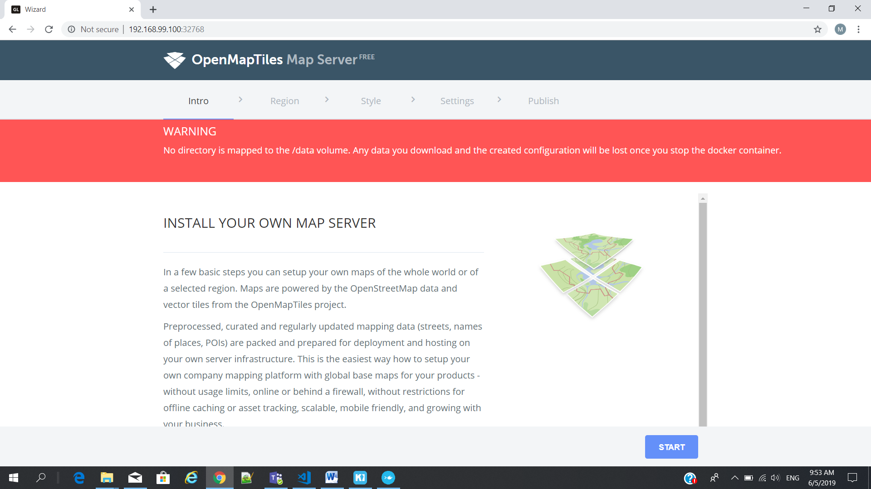

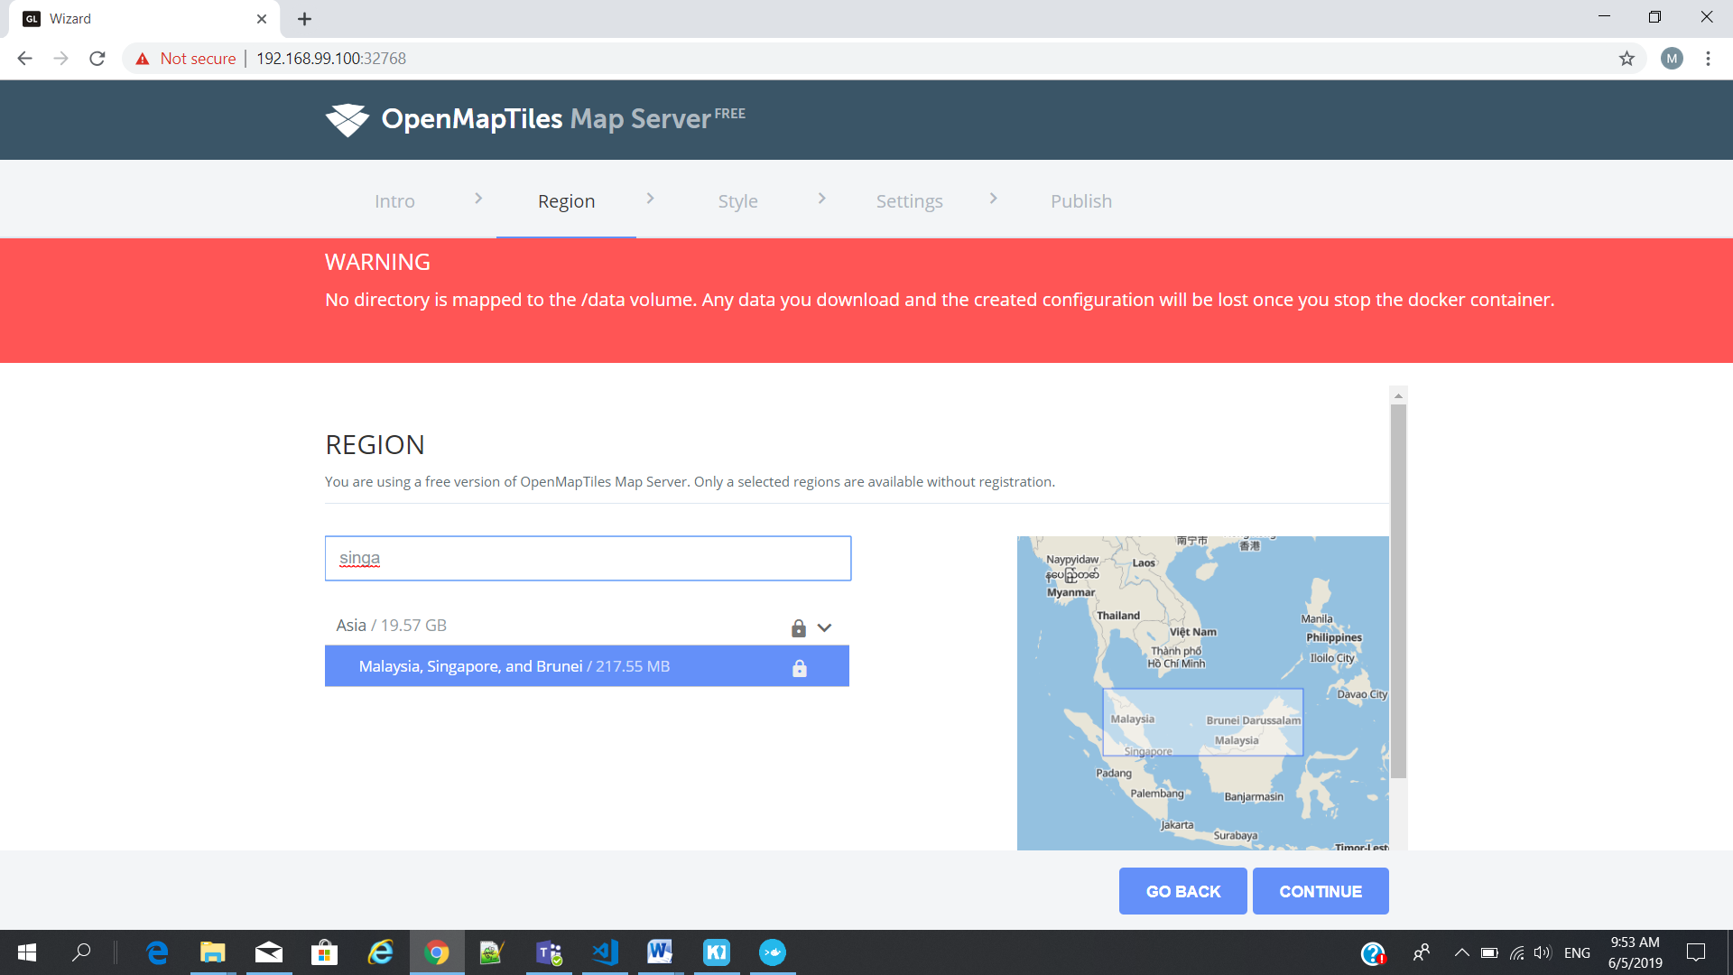

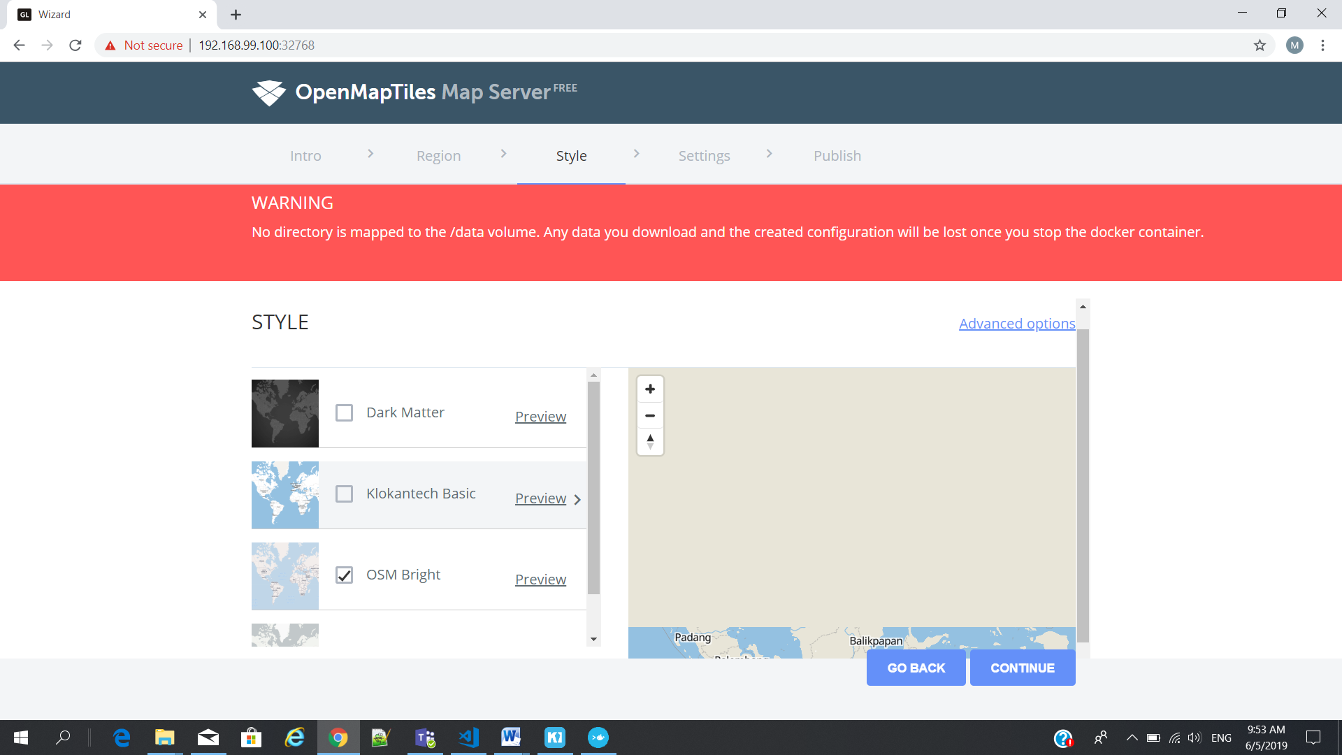

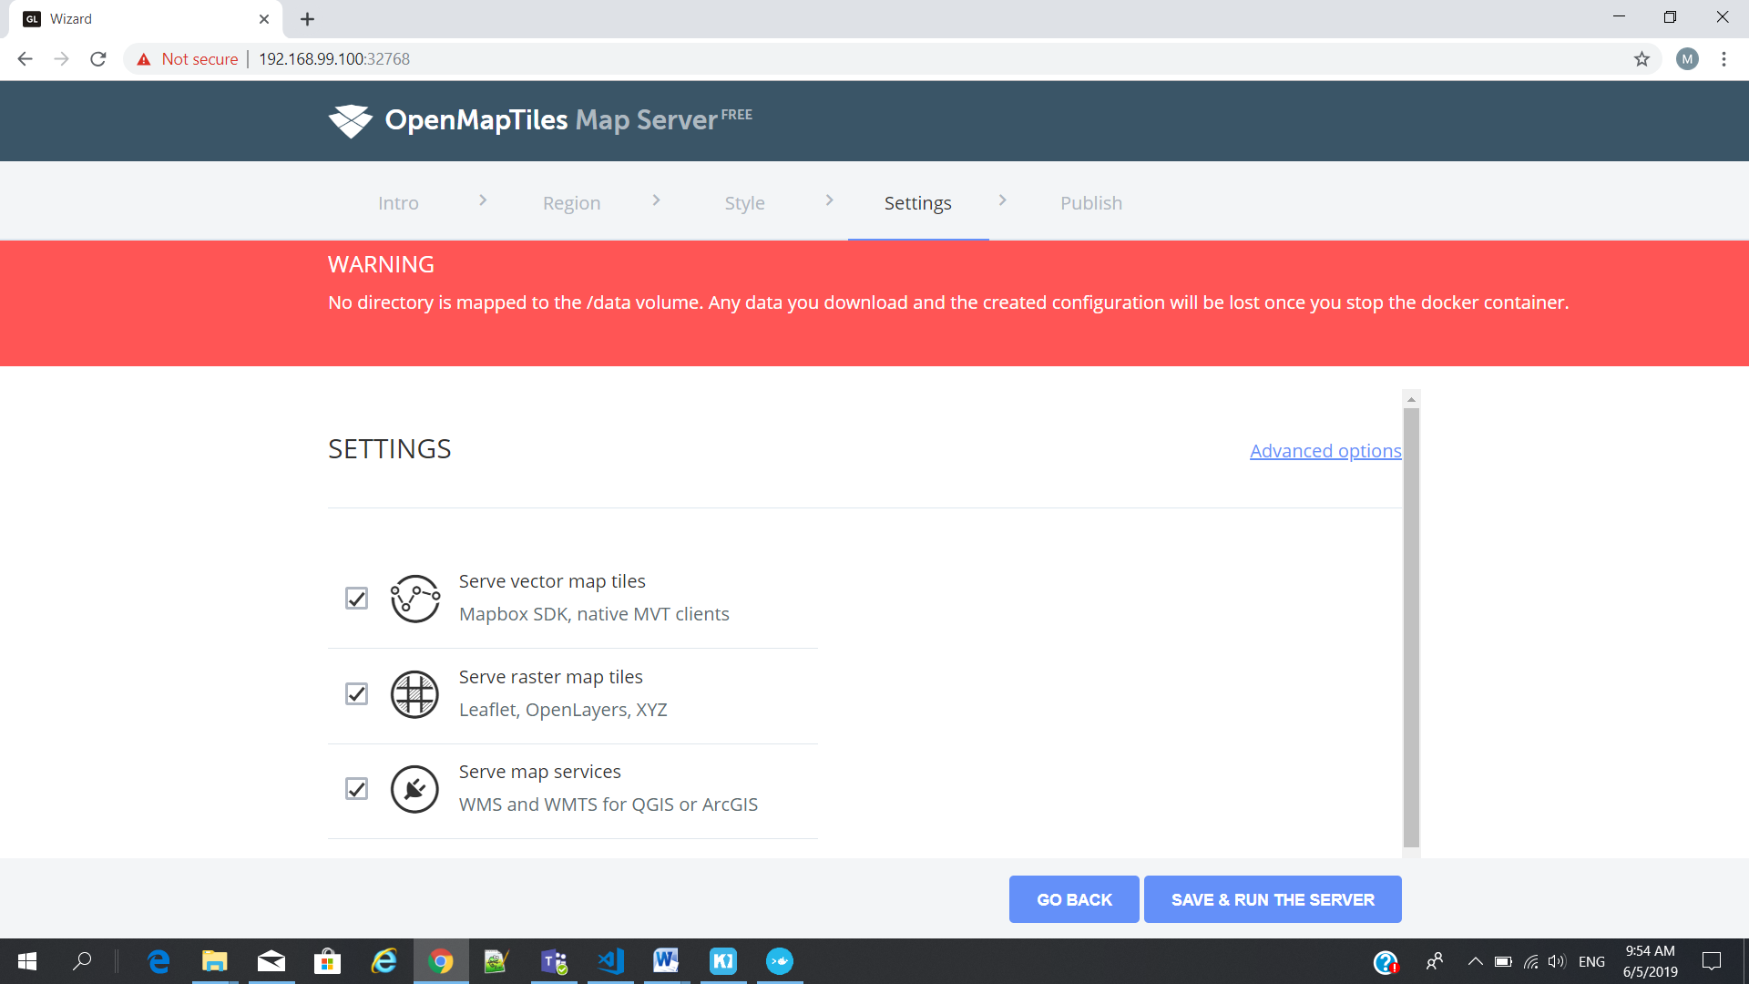

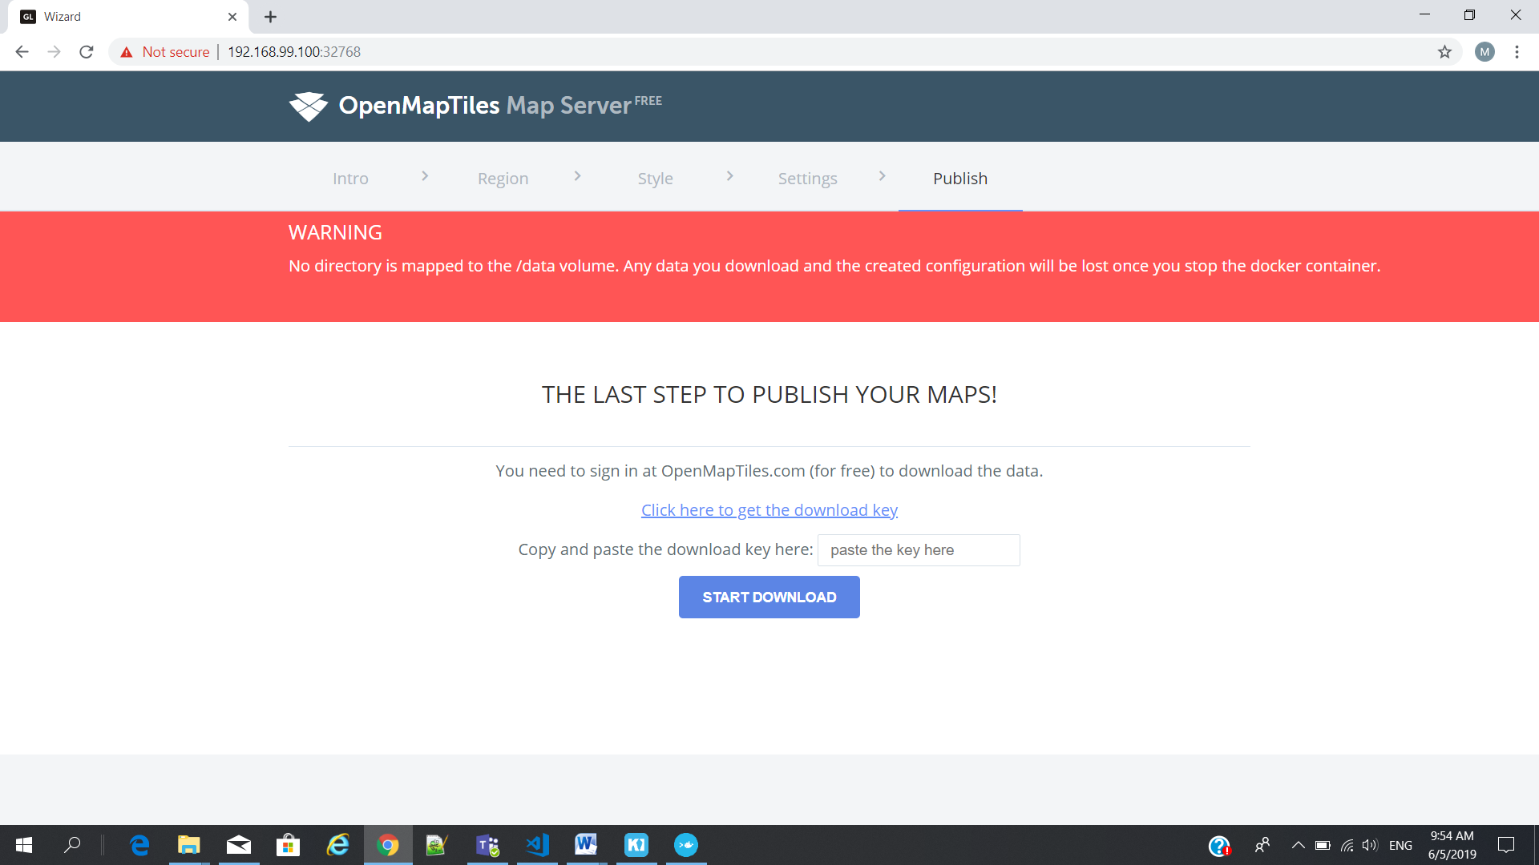

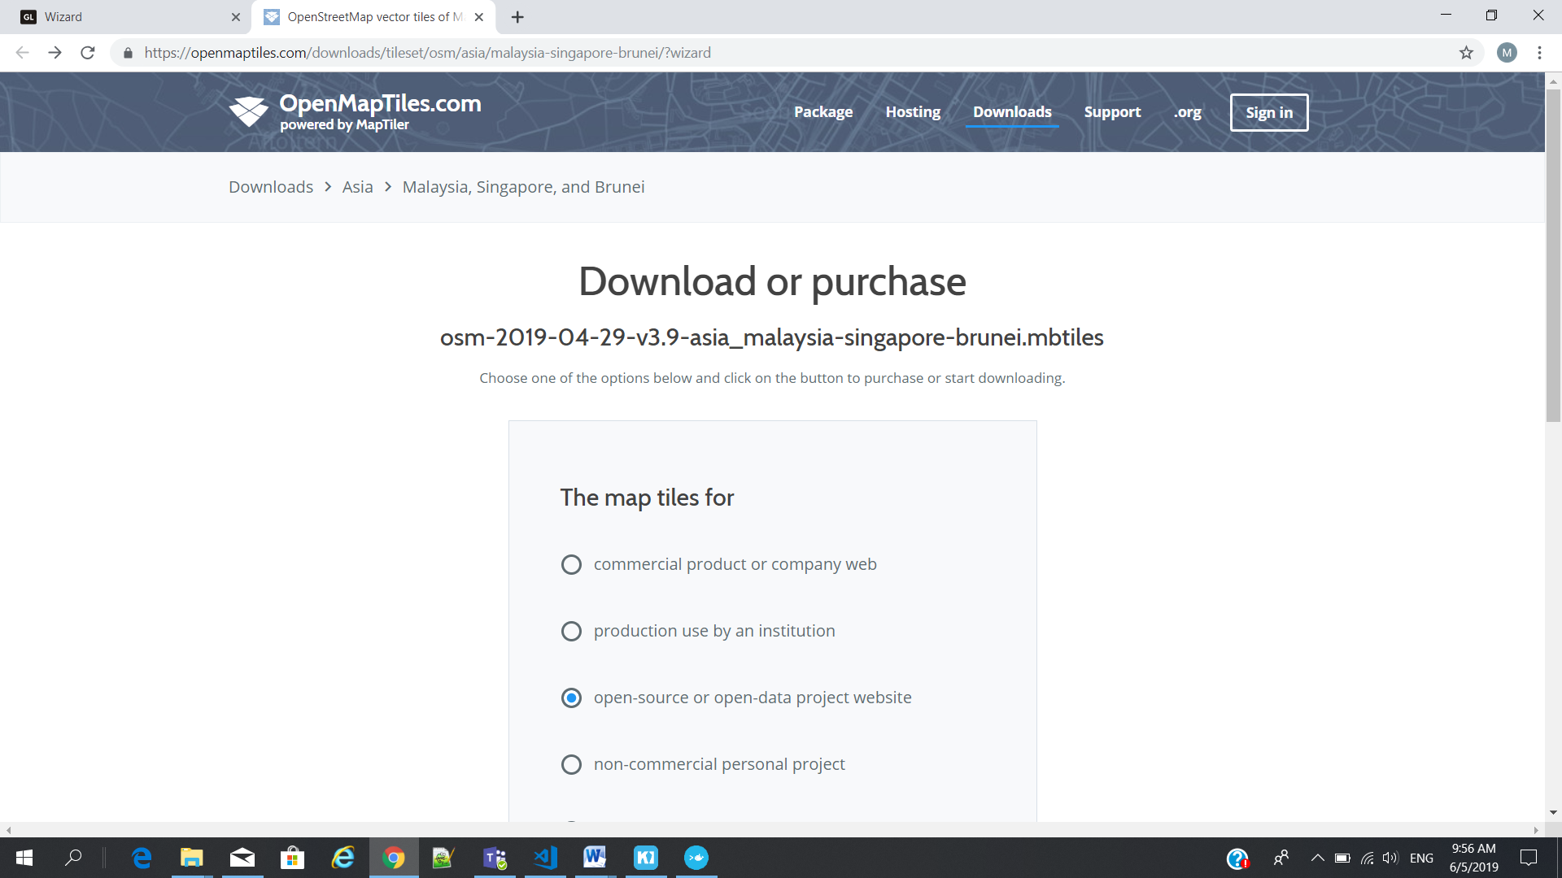

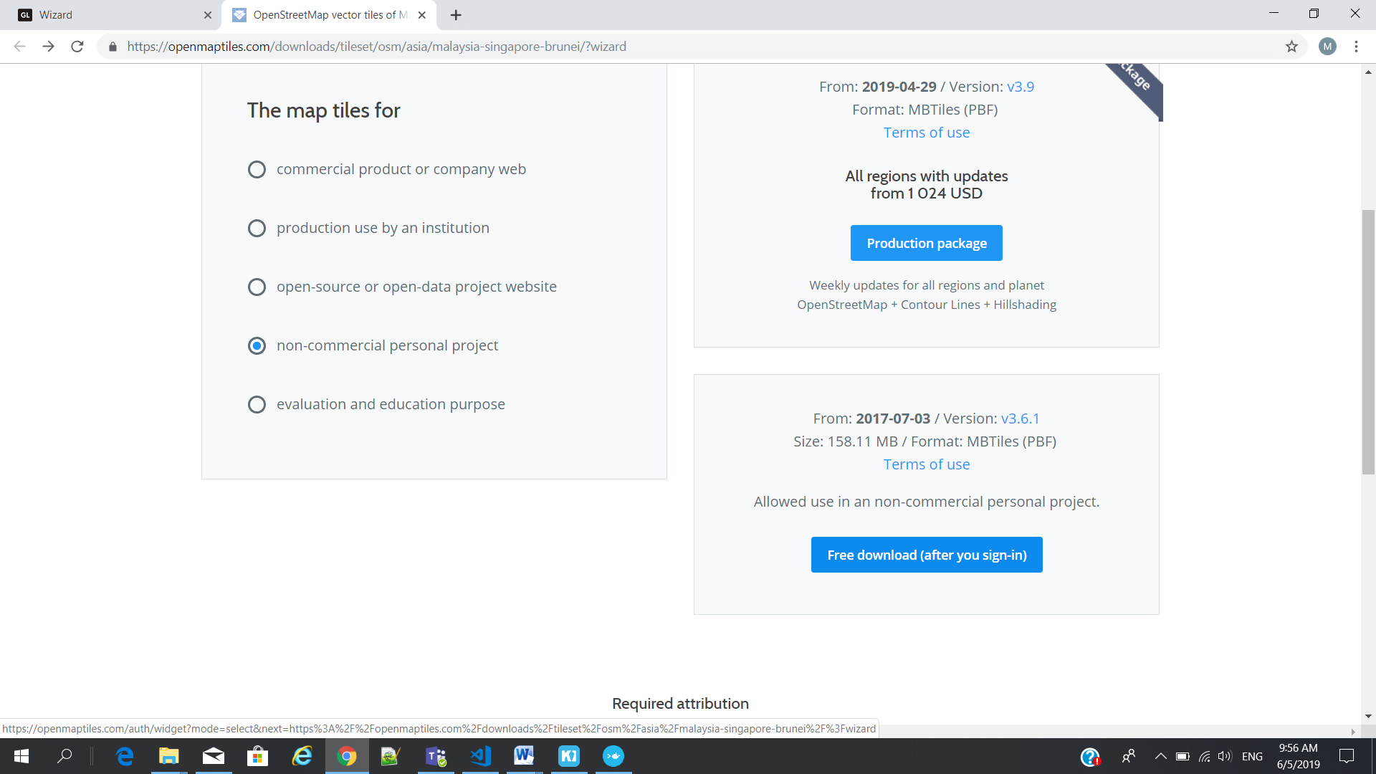

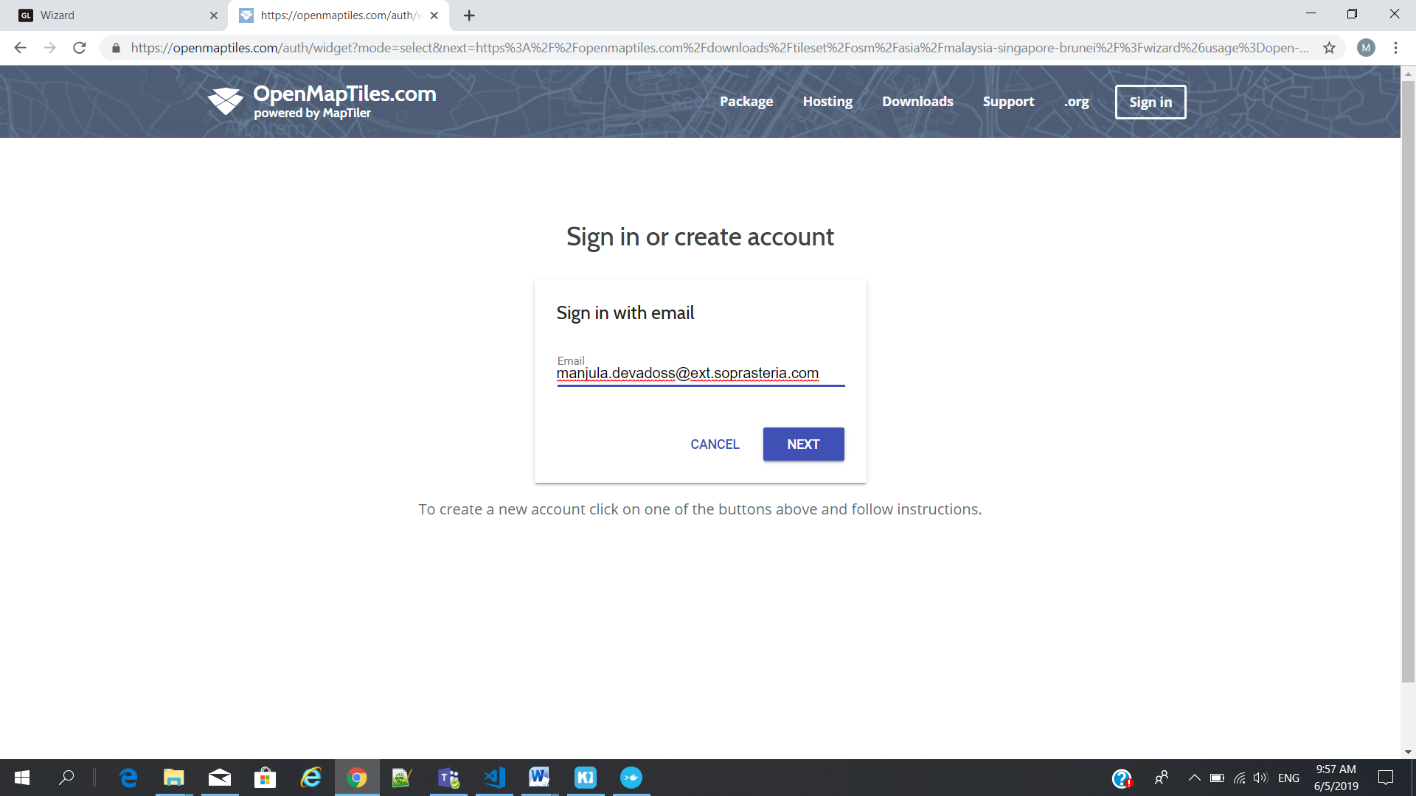

# Postgres Database Creation

1. Right click from Batabases(3)
2. Choose new Database

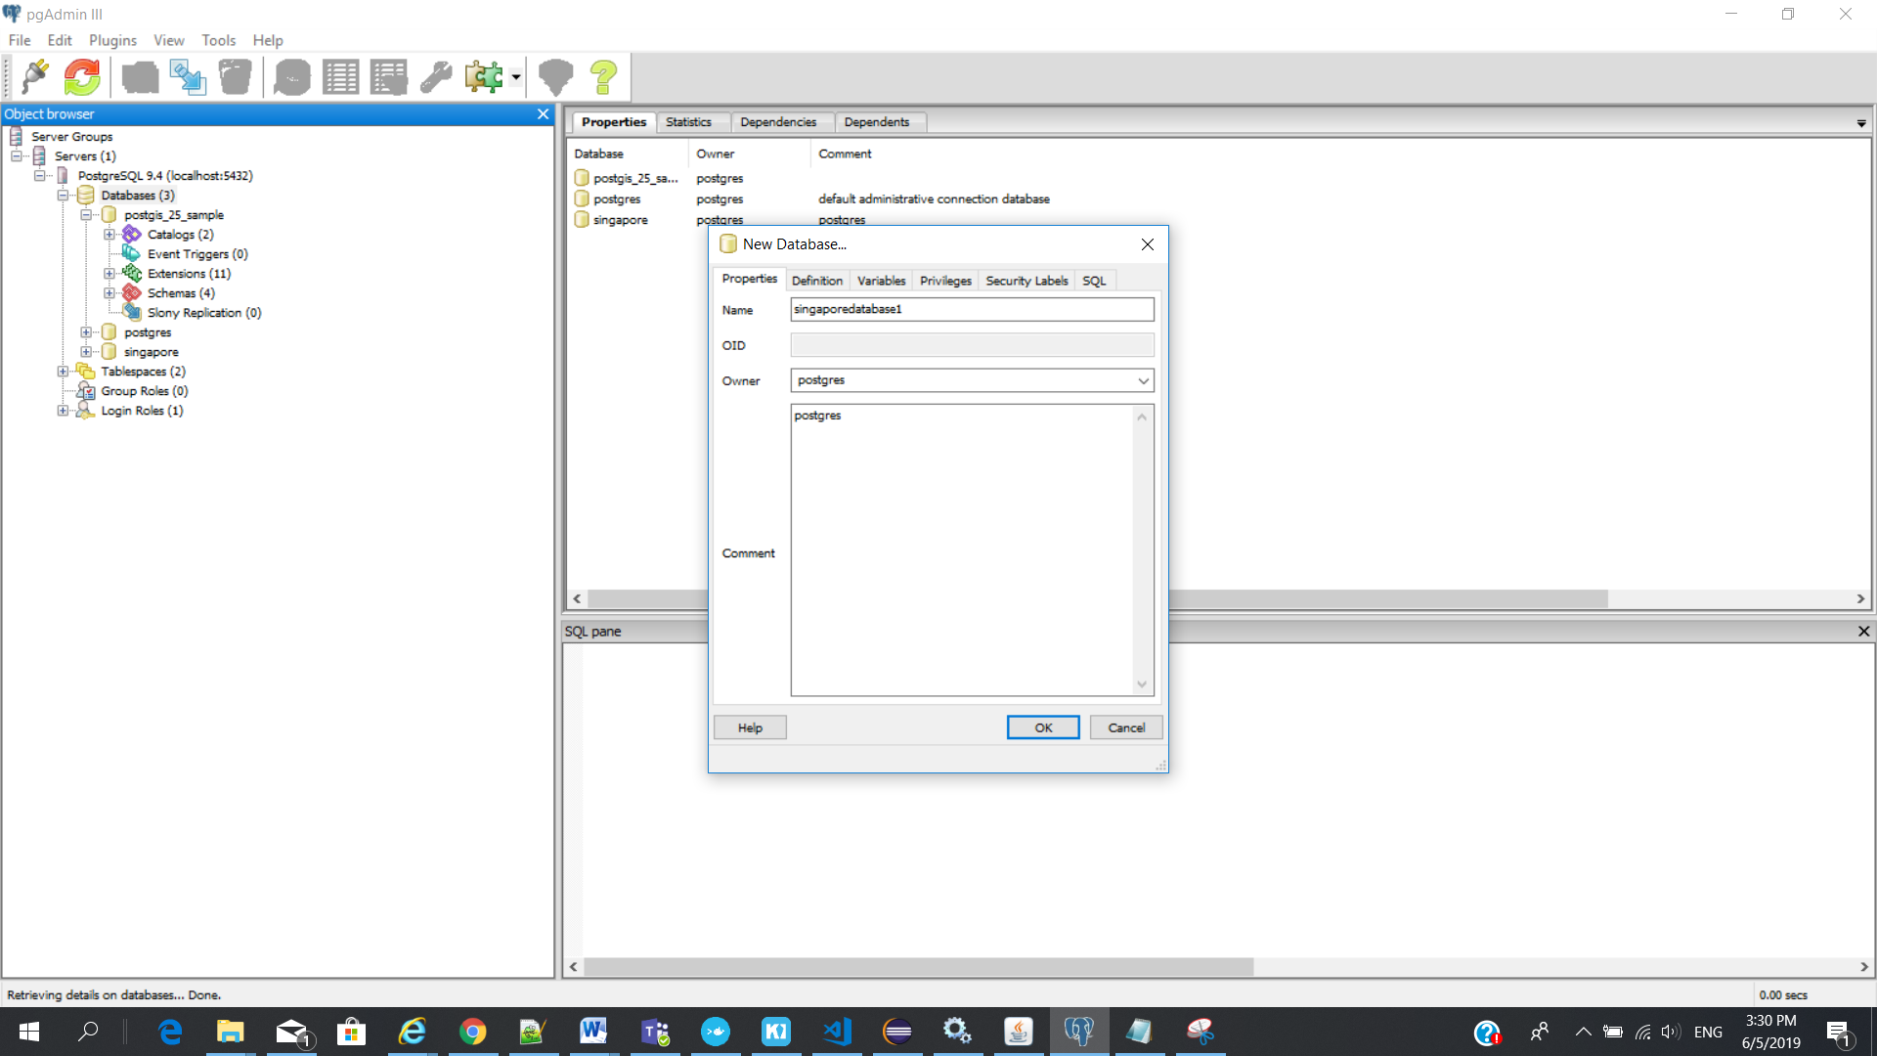

Template as - "postgis_25_sample"

Tablespace - pg_default

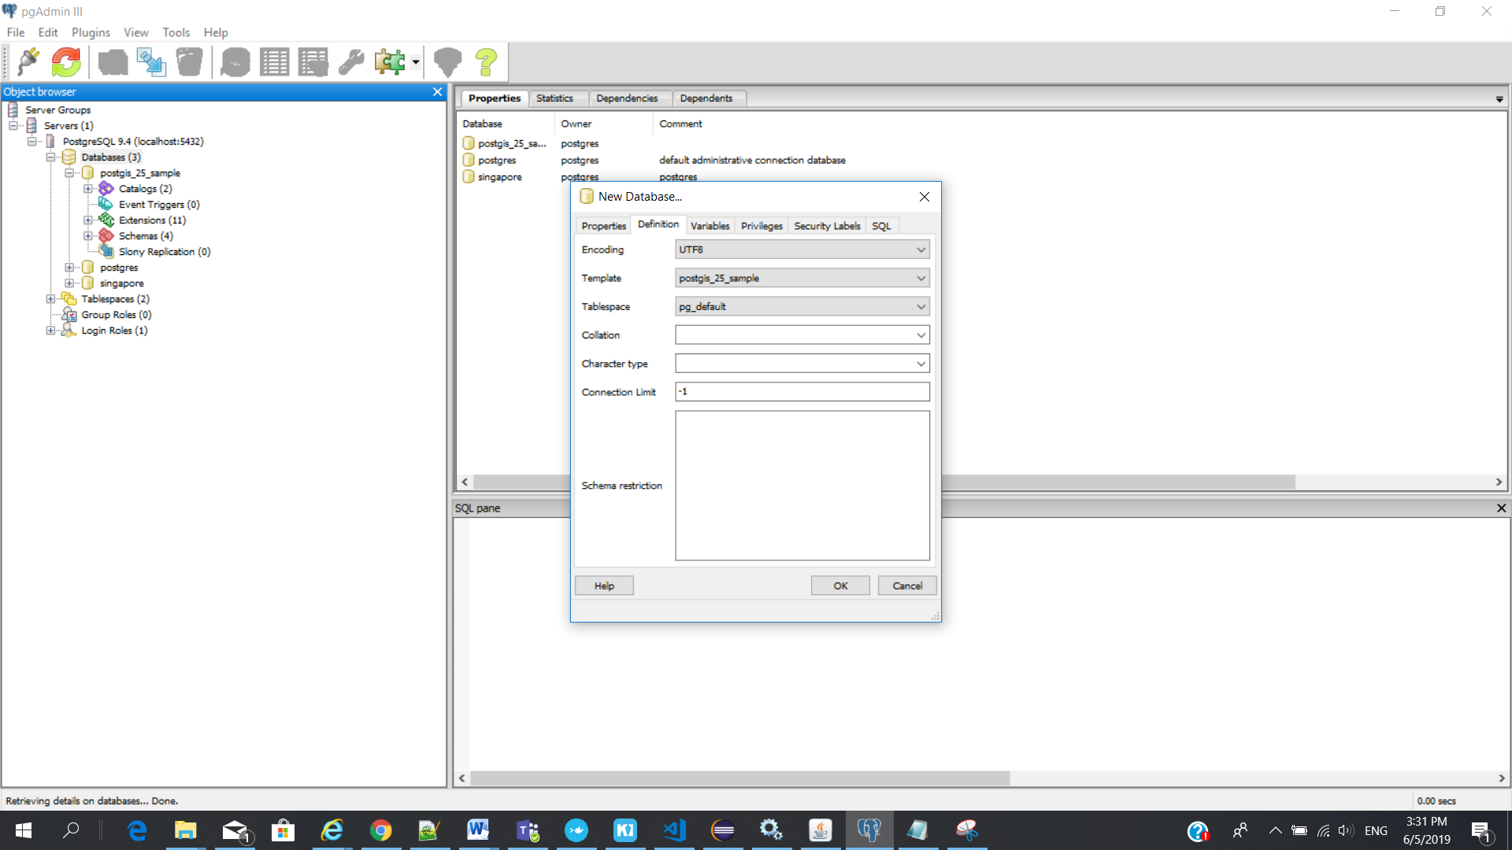

Make sure when you choose “postgis_25_sample” - Disconnect Database – cross icon on the label name

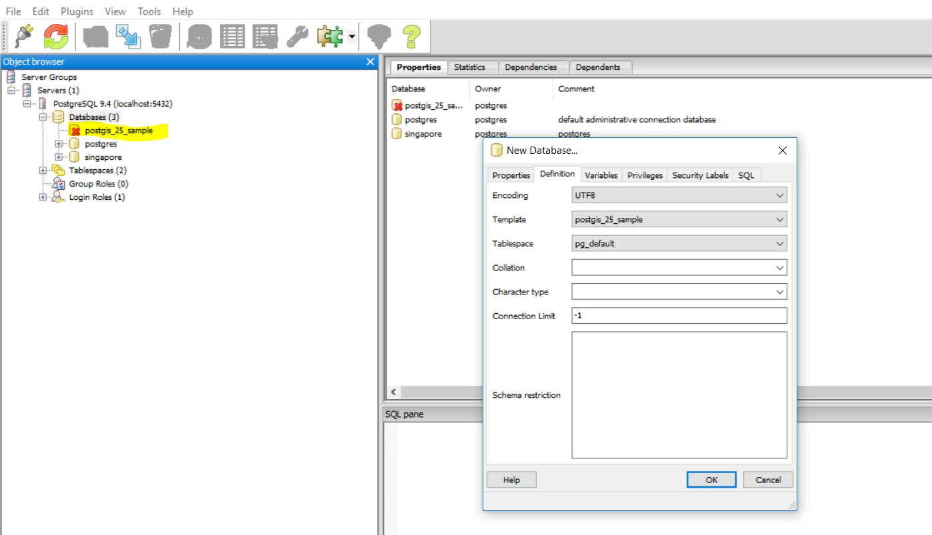

New database : singaporedatabase1

---- Singaporedatabase1

-------- Schemas

---------- Tables

--------- pointcloud_frmats(table)

---------- saptial_ref_sys(table)

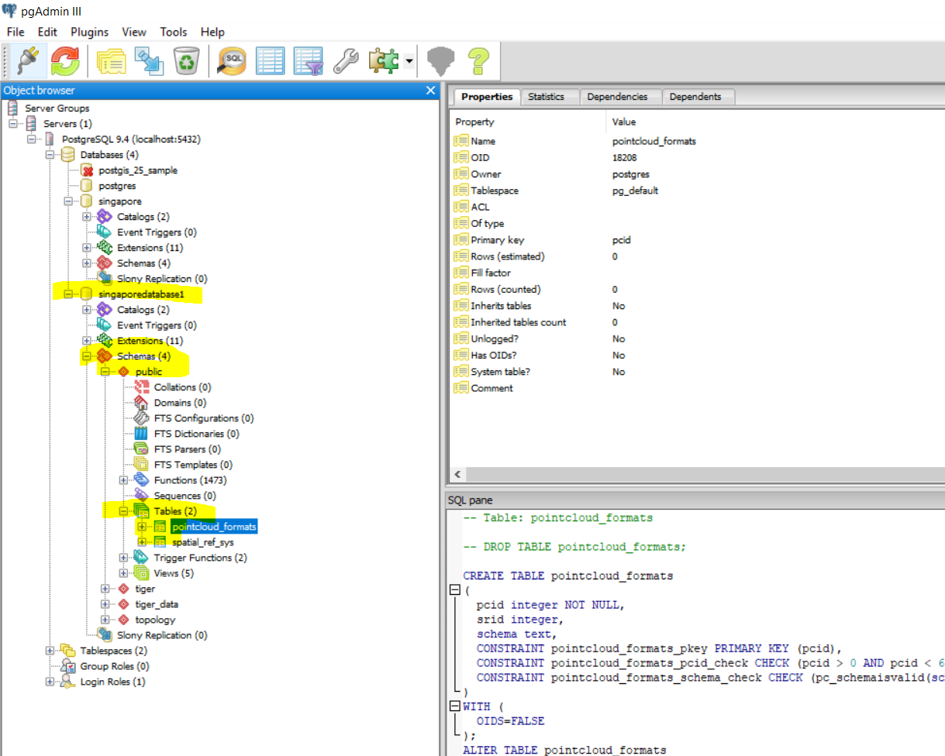

# Geoserver and database setup

Login to Geoserver ()

1. Click Workspace

Add new workspace

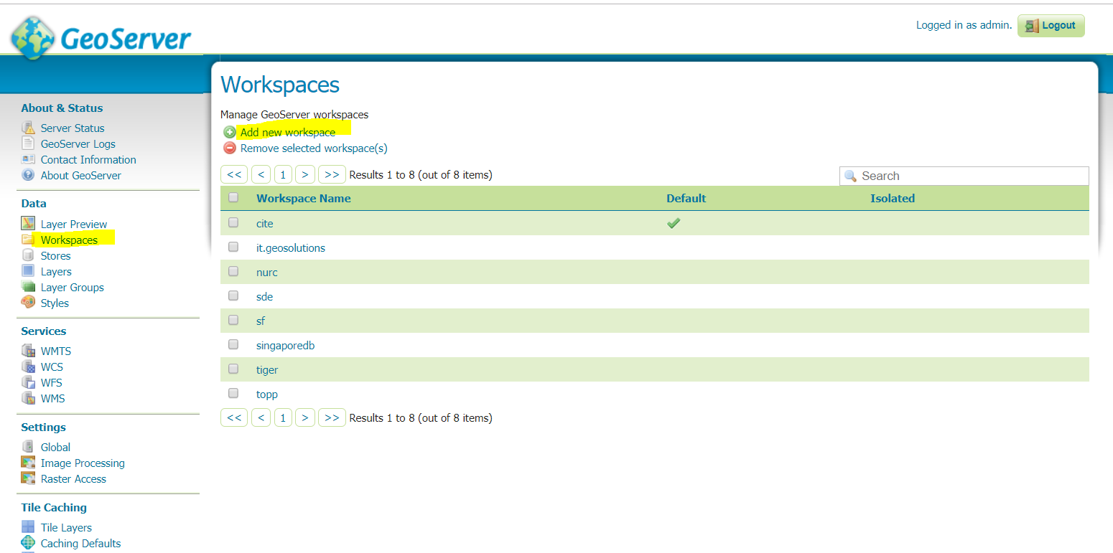

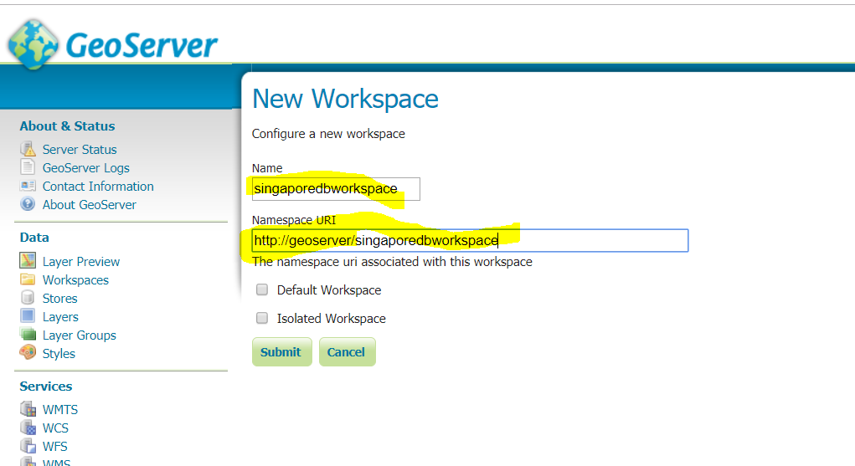

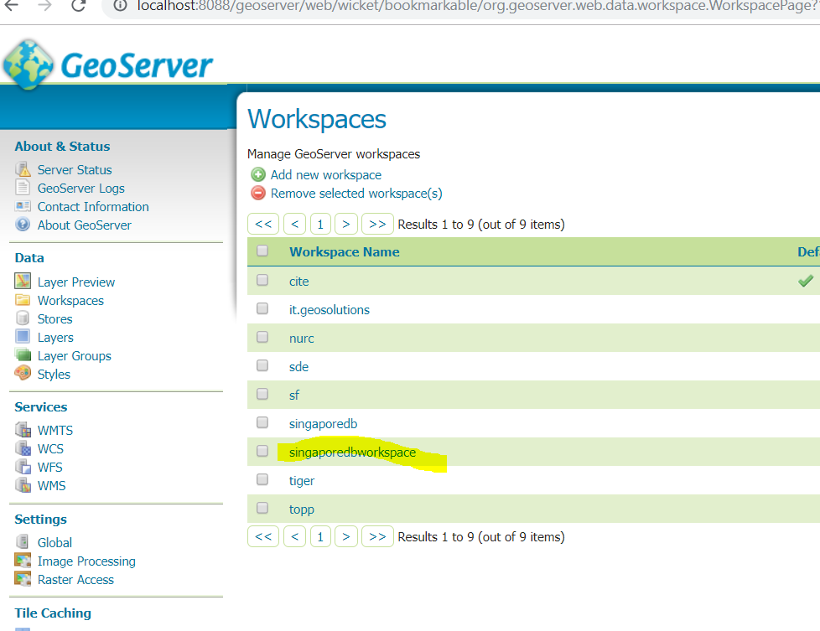

Services :

WMTS – Basemap (openmaptile server)

WMS – Additional layer (geoserver)

1. Click stores

Add new store

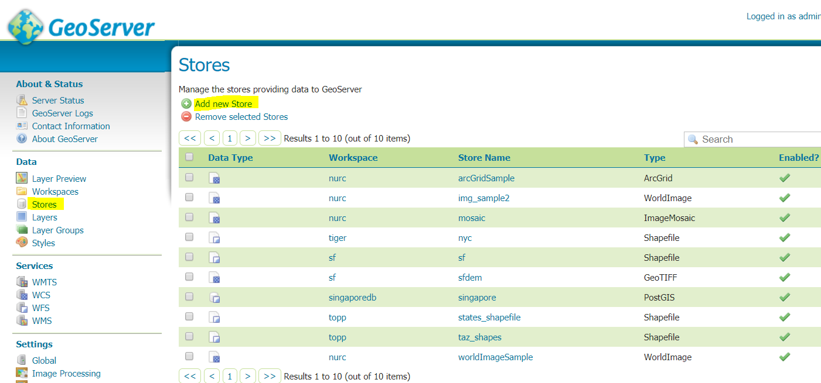

Choose :  [PostGIS](javascript:;)- PostGIS Database

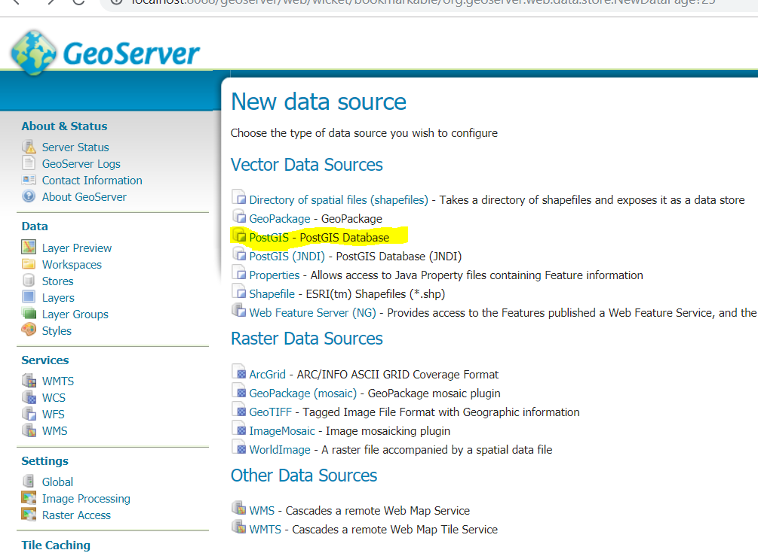

Click stores

Workspace – choose your workspace

Data Source Name – choose your data base name

Database – name of your database

User : postgres

password : postgres

maxconnection : 20

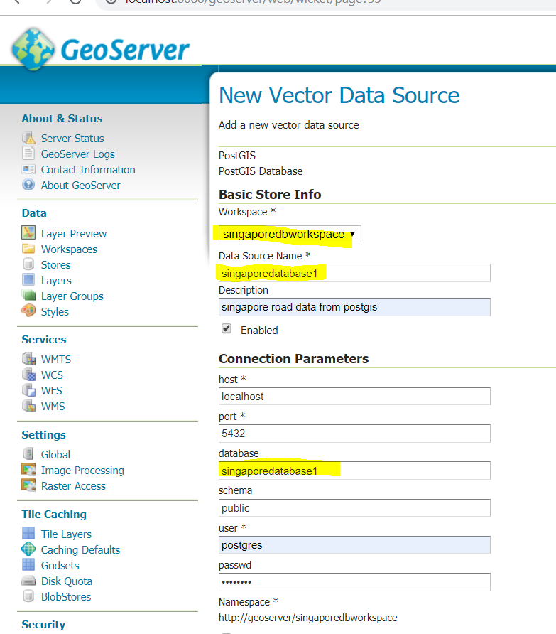

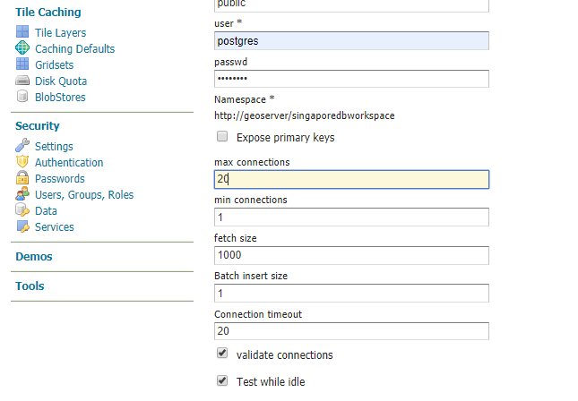

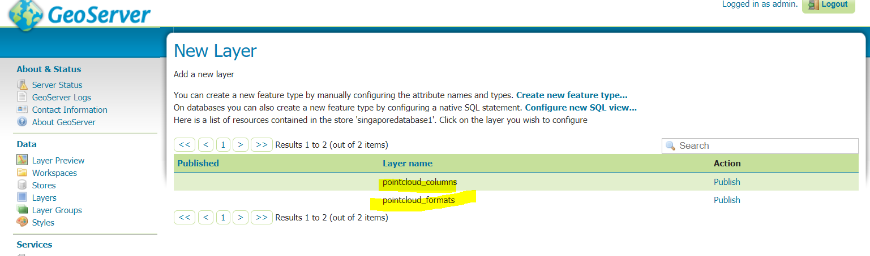

Layer will display : pointcloud_columns table (check with postgres db)

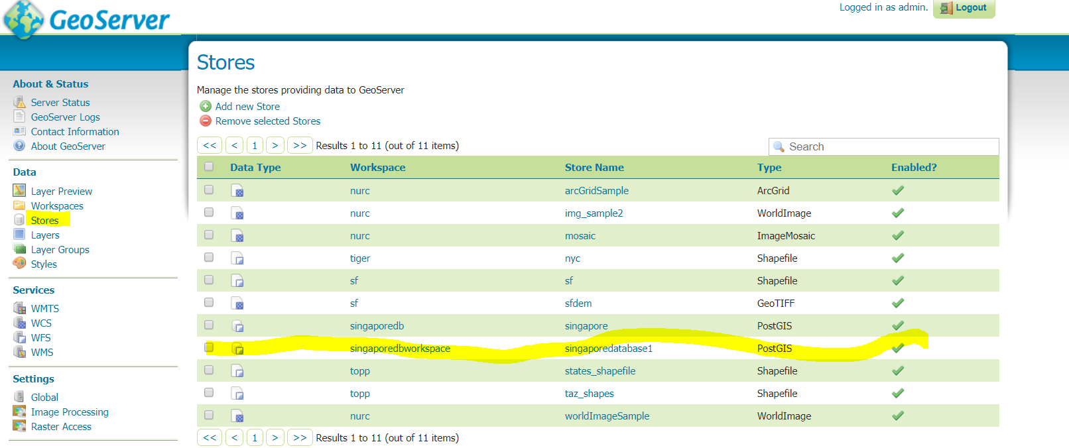

1. Click Layer

Add a new layer

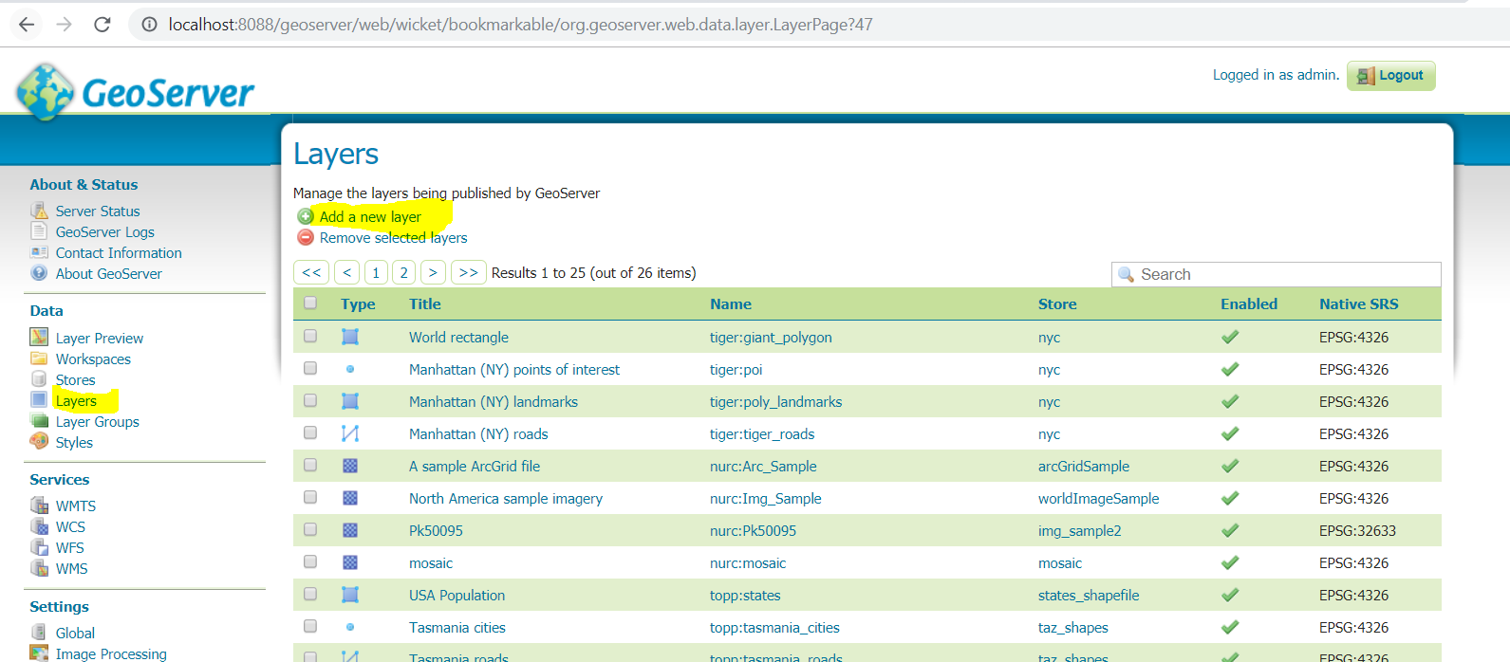

Choose you workspacename

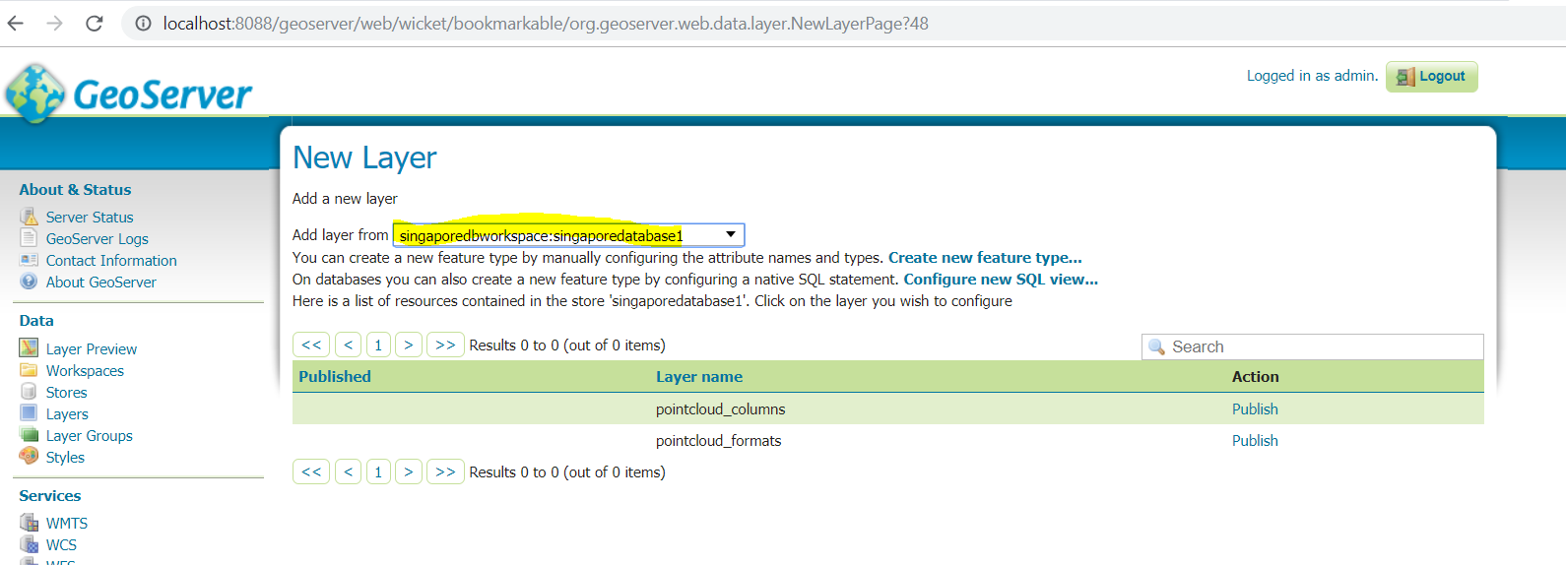

1. Click Layer Preview – to view the layer on the map

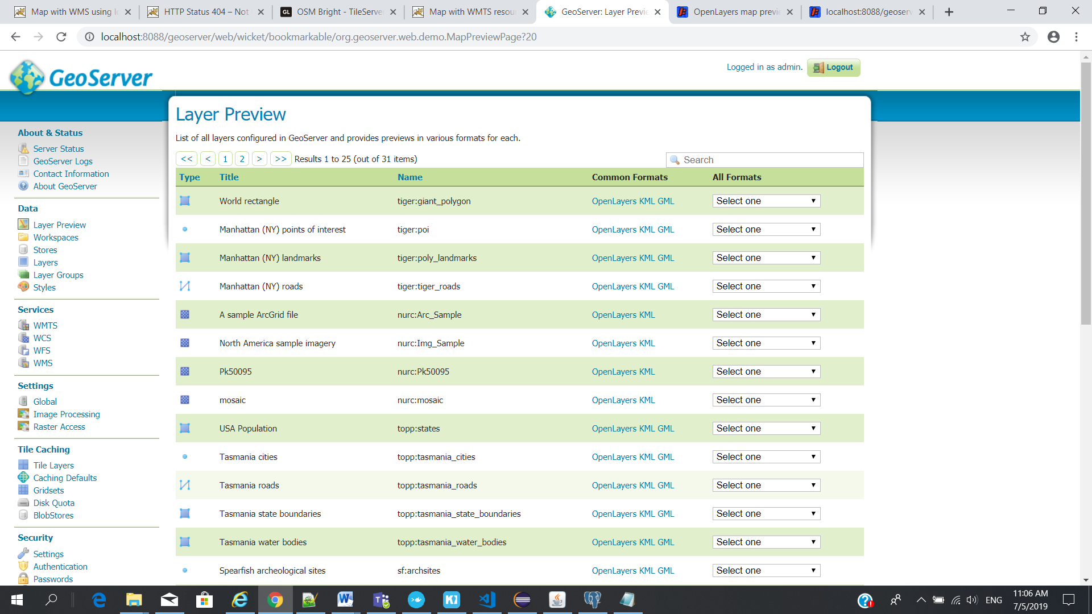

# [ArcGIS API for JavaScript 3.28](https://developers.arcgis.com/javascript/3/)

1. Download ArcGIS arcgis_js_v328_api. Choose the correct version and download
2. Installation html file available inside the zip file. Open and follow the instruction.
3. The ArcGIS API for JavaScript library can be copied in its entirety to your web server directory
4. you will need to edit some files to specify the baseUrl (www.example.com/arcgis_js_api/library/3.28/) for the default Dojo configuration.
5. Copy folder Library/3.28/ and paste it into your application main folder
6. Modify your file init.js/dojo.js

Using HTTP

Note: While not recommended, it is possible to host the ArcGIS API for JavaScript library using http. The dojo.js and init.js files would need modification to update https to http.  
Before: baseUrl:"https://www.example.com/arcgis_js_api/library/3.28/3.28/dojo"  
After: baseUrl:"http://www.example.com/arcgis_js_api/library/3.28/3.28/dojo"

<https://www.example.com/> - local folder location to http://localhost:8080/DemoTrans

Top of Form